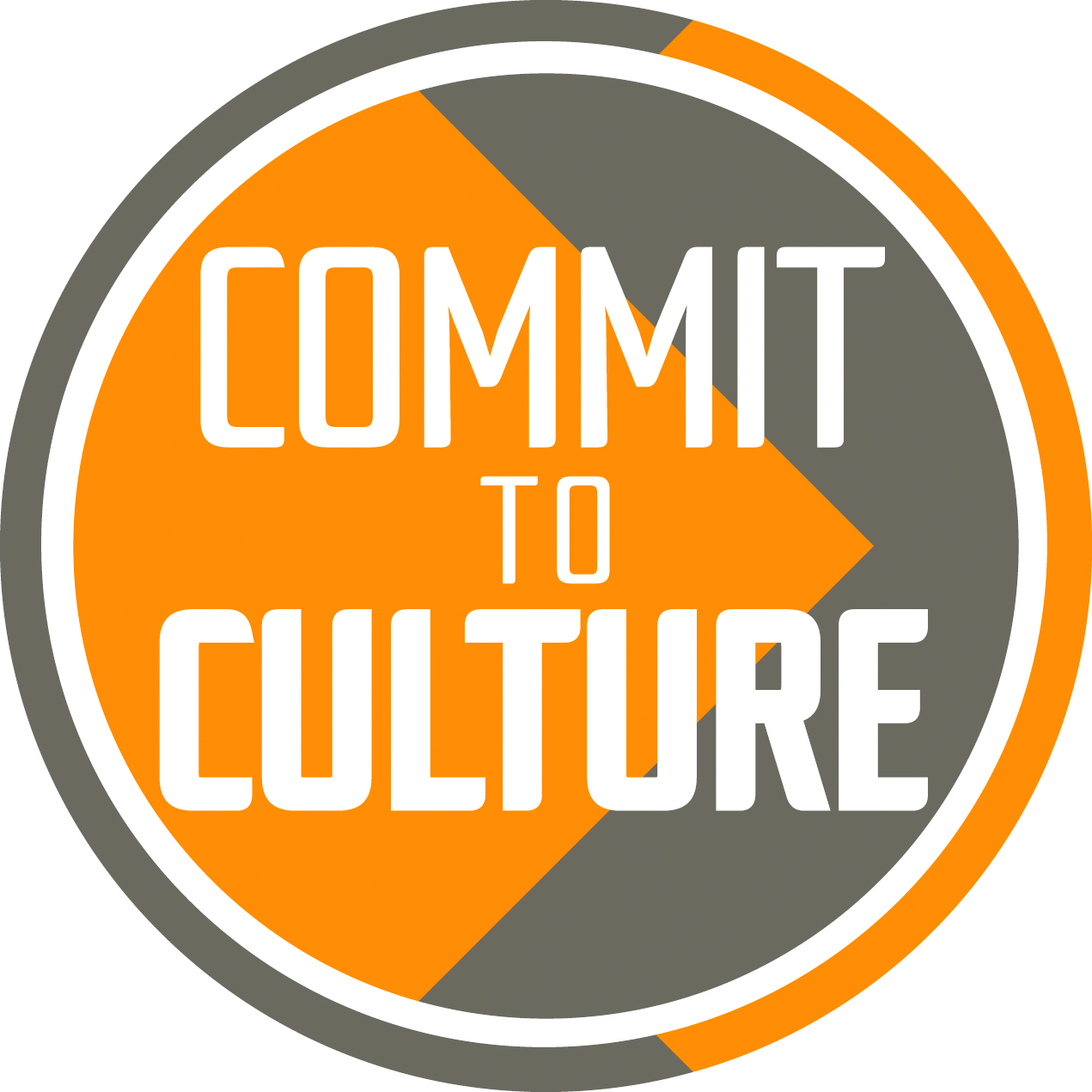

SMALL ARTS GRANT SCHEME 2017
YES WE’RE DOING IT AGAIN!

Following on the success of our 2015 Grants scheme Adur & Worthing Trust wants to commission more works of art – these could be in any shape or form, for example a painting, a performance, an intervention in the landscape, a piece of new music, a film ,a literary work or a new exciting event. Each work commissioned will receive £250- £500 grant to produce the artwork and an accompanying archive, which could be photographs, film, text or a combination of different media. This archive will be stored initially by The Adur & Worthing Trust. All work must be completed by the end of 2017 and this is a one-off scheme.

Each commission must:
- be shared with the public in some way
- demonstrate a link with the regeneration of Adur & Worthing (i.e. helping the area become a vibrant place, for both residents and visitors)
- be a new piece of art developed especially for this scheme
- network or partner two or more members of Worthing & Adur’s creative community
- promote the idea that Worthing & Adur is the creative area we know it to be!
Applications are to be submitted electronically by 27th February 2017. Winners will be announced and required to present their proposals to the panel at a networking event in April 2017. There will be advice and support available through Colonnade House prior to this event and the scheme launch will have additional promotion at the next meeting of the Worthing & Adur Creative Entertainment Movement.

A template document is available to submit your application, which must cover the following points:

- What your piece of work / event will be
- How it will be exhibited, shown or performed in Worthing or Adur, including a breakdown of overall costs
- Why the grant will help you develop this new piece of work, plus details of any other funding
- Which members from Adur & Worthing’s creative community will be involved
- How it promotes the idea of Adur & Worthing as a creative area
- How it relates to regeneration
- What the archive materials will be
- Other supporting information (e.g. whether you have had other submissions for funding or other commissions, etc)

The key criteria that your application will be judged on are as follows:

- Impact on Adur & Worthing’s regeneration
- Innovation and uniqueness of your idea / proposal
- Level of joined-up approach and partnership
- Promotion of Adur & Worthing as a creative area
- Quality of the proposal
- How this grant fits with the overall funding of your proposal
- Sustainability and legacy of your proposal

Application forms

Application forms are available on the Colonnade House website: www.colonnadehouse.co.uk or on request from k.simporis1@ntlworld.com

Approval Process

An independent panel representing Worthing and Adur Arts will manage the process on behalf of Adur and Worthing Trust. All winning applicants will be formally notified by March 31st 2017 and will be issued a formal agreement to complete and return. Half of the funds awarded will be given on receipt of a signed agreement and the other half on presentation of the archive to The Adur & Worthing Trust.

So…

Get your thinking caps on and those creative brains fizzing and we look forward to seeing all of your ideas!

The very best of luck!

Karen Simporis

On behalf of Adur and Worthing Trust

Adur and Worthing Trust is a limited company and registered charity, no: 1156999
Our aim is to promote arts, culture and heritage across Adur and Worthing

We are an active partner in the Commit to Culture Partnership which encourages inclusive cultural activities, expanding opportunities to participate in the arts, raising the profile and reputation of Adur and Worthing for cultural excellence and innovation.

