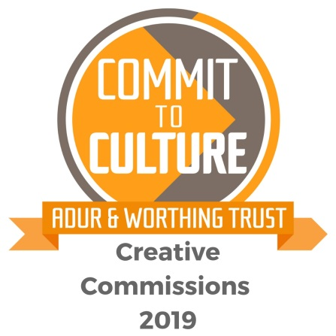

YES WE’RE DOING IT AGAIN!

Following on the success of our 2017 scheme Adur & Worthing Trust wants to commission more works of art – these could be in any shape or form, for example a painting, a performance, an intervention in the landscape, a piece of new music, a film ,a literary work or a new exciting event.

Each work commissioned will receive £250- £500 to produce the artwork and an accompanying archive that will be submitted to Adur & Worthing Trust at the end of the project – this could be photographs, film, text or a combination of different media.

All work must be completed by the end of 2019 and this is a one-off scheme.

Our criteria
Each commission must:
- be shared with the public in some way
- demonstrate a link with the regeneration of Adur & Worthing (i.e. helping the area become a vibrant place, for both residents and visitors)
- be a new piece of art developed especially for this scheme
- network or partner two or more members of Worthing & Adur’s creative community
- promote the idea that Worthing & Adur is the creative area we know it to be!

There will be advice and support available through Colonnade House.

In the Studio Gallery there will be an exhibition of past commissions and information from 22nd January – 2nd February and the scheme launch event will take place on 30th January 5 – 7pm.

Book your place for the launch here: https://awtcreativecommissions2019.eventbrite.co.uk

How to Apply

You must use the AWT Creative Commissions 2019 application form. Your application must cover the following points:

- What your piece of work / event will be
- How it will be exhibited, shown or performed in Worthing or Adur, including a breakdown of overall costs
- Why the funding will help you develop this new piece of work, plus details of any other funding
- Which members from Adur & Worthing’s creative community will be involved
- How it promotes the idea of Adur & Worthing as a creative area
- How it relates to regeneration
- What the archive materials will be
- Other supporting information (e.g. whether you have had other submissions for funding or other commissions, etc)

The key criteria that your application will be judged on are as follows:

- Impact on Adur & Worthing’s regeneration
- Innovation and uniqueness of your idea / proposal
- Level of joined-up approach and partnership
- Promotion of Adur & Worthing as a creative area
- Quality of the proposal
- How this commission fits with the overall funding of your proposal
- Sustainability and legacy of your proposal

Application forms are available from 1st January on the Colonnade House website: https://colonnadehouse.co.uk/event/awt-creative-commissions-2019/

Applications are to be submitted electronically by midnight Sunday 3rd March 2019. Successful applications will be announced by Thursday 21st March 2019.

Selection Process

An independent panel representing Worthing and Adur Arts will manage the process on behalf of Adur and Worthing Trust. All winning applicants will be formally notified by March 21st 2019 and will be issued a formal agreement to complete and return. Half of the funds awarded will be given on receipt of a signed agreement and the other half on presentation of the archive to The Adur & Worthing Trust.

So…

Get your thinking caps on and those creative brains fizzing and we look forward to seeing all of your ideas!

The very best of luck!

Karen Simporis

On behalf of Adur and Worthing Trust

Adur and Worthing Trust is a limited company and registered charity, no: 1156999
Our aim is to promote arts, culture and heritage across Adur and Worthing

We are an active partner in the Commit to Culture Partnership which encourages inclusive cultural activities, expanding opportunities to participate in the arts, raising the profile and reputation of Adur and Worthing for cultural excellence and innovation.

